

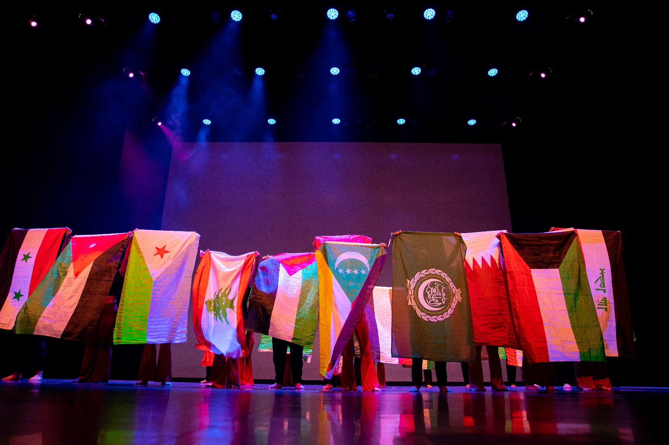

*UB International Fiesta, Organization of Arab Students (OAS) performance, March 2022.*

*Photographer: Meredith Forrest Kulwicki*

**UNIVERSITY AT BUFFALO INVITES YOU TO CELEBRATE:**

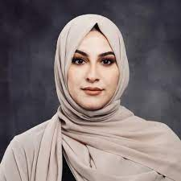

moderated by:

Shareefa Albanna

Startup Success Manager,

UB Business & Entrepreneur

Partnerships

UB’s Inaugural Arab American

Heritage Month Celebration

Please join us to celebrate Eid Al Fitr and April’s designation of Arab American Heritage Month for the first time here at UB!  We will be hosting several local Arab American leaders to talk about what these events mean to them as well as their experiences and achievements in our local community.  Arabic themed hors d’oeuvres and desserts will be available.

All University community members including alumni are welcome.

**DATE:** Tuesday, April 25, 2023

**TIME:** 3:00 pm – 4:30 pm

**LOCATION:** Student Union 210 (Landmark Room)

**REGISTRATION:** Please RSVP via [webform](https://forms.office.com/r/mJfvA1jvxn) for planning purposes

**SPONSORED BY:**  Office of Inclusive Excellence & PSS Inclusion and Diversity Committee